oprator's manual

Contents

INTRODUCTION 0

Intended use 0

GRAPHIC WARNINGS 0

SAFETY WARNINGS 0

PRODUCT DESCRIPTION 0

TECHNICAL DATA 0

ASSEMBLY INSTRUCTIONS 0

UNPACKING 0

Packing contents 0

Installing the cutting line spool 0

Installing the cutting head shield 0

OPERATIONS 0

ADDING/CHECKING ENGINE LUBRICANT 0

FUELING AND REFUELING THE TRIMMER 0

Starting and stopping 0

To start a cold engine: 0

To restart a warm engine: 0

To stop the engine: 0

IF ASSISTANCE IS REQUIRED FOR THIS PRODUCT: 0

OPERATING THE TRIMMER 0

Engage cutting head spool/ Stop 0

Working 0

To adjust the trimming line length 0

Tips for best trimming 0

CLEANING AND CARE 0

MAINTENANCE 0

Inspection and maintenance item and interval by operator 0

Engine lubricant Oil Replacement: 0

Air Filter Cleaning 0

Inspect the Spark Plug 0

Cutting line spool 0

Carburettor 0

AFTERSALES SERVICE 0

DISPOSAL 0

STORAGE 0

# INTRODUCTION

Thank you for your purchasing the String trimmer from SENIX . The present manual explains how to handle the string trimmer well. Before using it, please read this operator’s manual carefully, operate the trimmer correctly and engage in your task safely.

## Intended use

The string trimmer is intended to trim grass. This string trimmer may not be used to do other thing out of the described scope.

## GRAPHIC WARNINGS

Because a trimmer is a high-speed, fast cutting garden tool, special safety precaution must be observed to reduce the risk of personal injury. Read this manual carefully. Be familiar with the controls and the proper use of the unit. Know how to shut it off, and how to unhook a harnessed unit quickly.

**SYMBOL** **NAME** **MEANING**

|  |  |  |
| --- | --- | --- |
| Image media/image2.wmf missing | Safety Alert | This graphic accompanied by the words WARNING ,DANGER OR CAUTION calls attention to an act of a condition which can lead to SERIOUS INJURY. |
|  | Read Operator’s Manual | Read the operator’s manual(s) and follow all warnings and safety instructions. Failure to do so can result in serious injury to the operator and/or bystanders. |
|  | Wear eye and hearing protection | ALWAYS WEAR EYE PROTECTION, EAR PROTECTION AND HEAD PROTECTION meeting ANSI Z87.1 strandards. |
|  | WEAR FOOT PROTECTION | WEAR FOOT PROTECTION |
|  | WEAR GLOVES | WEAR GLOVES |
|  |  | BEWARE OF FOOT INJURY BY CUTTING ATTACHMENT |
|  |  | BEWARE OF THROWN OBJECTS HIT BY CUTTING ATTACHMENTS. NEVER USE WITHOUT PROPERLY MOUNTED PROTECTING GUARD. |
|  |  | KEEP 15 METERS AWAY FROM ANY OTHER PERSON |
|  |  | BEWARE OF THROWN OBJECTS HIT BY CUTTING ATTACHMENTS. NEVER USE WITHOUT PROPERLY MOUNTED PROTECTING GUARD. |
| Image media/image12.emf missing |  | Don’t install or use any type of blade on the unit displaying this symbol. |

Specifications, descriptions and illustrative material in this manual are as accurate as known at the time of publication, but are subject to change without notice. Illustrations may include optional equipment and accessories, and may not include all standard equipment.

## SAFETY WARNINGS

1. Proper safety precautions must be observed. Like all power equipment this unit must be handled carefully. DO NOT EXPOSE YOURSELF OR OTHERS TO DANGER. Follow these general rules. Do not permit others to use this unit unless they are thoroughly responsible and have read, and understand the string trimmer manual and are trained in its operation.
2. Always wear safety goggles for eye protection. Dress properly, do not wear loose clothing or jewelry that could become caught in moving parts of the unit. Safe, sturdy, nonskid footwear should always be worn. Long hair should be tied back. It is recommended that legs and feet should be covered to protect from flying debris during operation.
3. Inspect the entire unit for loose parts (nuts, bolts, screws, etc.) and any damage before start and operation. Repair or replace as necessary before using the machine.
4. DO NOT USE any attachment with this power head other than the ones recommended by our manufacture’s replacement. Serious injury to the operator or bystanders could result as well as damage to the machine.
5. Keep the handles free from oil and fuel.
6. Do not operate the unit at insufficient lighting condition.
7. Do not operate the unit when you are tired, when your concentration is impaired and/or under the influence of drugs, medication or alcohol.
8. Always use proper handles when trimming.
9. Do not smoke while filling tank.
10. Do not fill fuel in an enclosed room or near open flames. Ensure adequate ventilation.
11. Always store fuel in a properly marked container that is approved by local codes and ordinances for such usage.
12. Never remove the fuel tank cap while the engine is running.
13. Never start or run the product inside a closed room or building. Fumes from the exhaust contain dangerous carbon monoxide.
14. Never attempt to make engine adjustments while the unit is running. Always make engine adjustments with the unit resting on a flat, clear surface.
15. Do not use the unit if it is damaged or poorly adjusted. Never remove the unit’s guard. Serious injury to the operator or bystanders could result as well as damage to the machine.
16. Inspect the area to be cut and remove all debris that could become entangled in the nylon cutting head. Also remove any objects that the unit may throw during cutting.
17. Keep children away. Onlookers should be kept at a safe distance from the work area, at least 15 METER (50 FEET).
18. Never leave the unit unattended while engine is runnig.
19. Do not use this unit for any job other than those for which it is intended as described in this manual.
20. Do not overreach. Keep proper footing and balance at all times. Do not run the unit while standing on a ladder or on any other unstable footing location.
21. Keep hands and feet in safe distance from the nylon cutting line while unit is in use.
22. Do not use this type of unit for sweeping away debris.
23. Use nylon cutting head which is free of damage. If a stone or any other obstacle is hit, stop the engine and check the nylon cutting head. A broken or unbalanced nylon cutting head must never be used.
24. FOLLOW INSTRUCTION FOR assembling ACCESSORIES.
25. Do not store the unit in a closed area where fuel vapors can reach an open flame from hot water heaters, furnaces, etc. Store in a locked, well ventilated area only.
26. Ensure safe and proper performance of your unit. Please only use original accessories. The use of any other accessories or attachments may cause a potential hazard or injury to the user, damage to the unit and void this warranty.
27. Clean the unit completely, especially, the fuel/oil tank, its surroundings, and the air cleaner, if the unit will not be used for long time.
28. When refueling, be sure to stop the engine and confirm that it is cooled down. Never refuel when the engine is running or hot. When gasoline spills, be sure to wipe it up completely and dispose of those materials before starting the engine.
29. Stay clear of other workers or bystanders by at least 15 meters/50 feet.
30. Whenever approaching an operator of the unit, carefully call his attention and confirm that the operator stop the engine. Be careful not to startle or distract the operator which can cause an unsafe situation.
31. Never touch the nylon cutting head whenever the engine is running. If it is necessary to adjust the protector or nylon cutting head, be sure to stop the engine and confirm that the nylon cutting head has stopped running.
32. The engine should be turned off when the machine is moved between work areas.
33. Be careful not to hit the nylon cutting head against stones, or the ground. Unreasonable rough operation will shorten the life of the unit as well as create an unsafe environment for yourself and those around you.
34. Pay attention to loosening and overheating parts. If there is any abnormality of the unit, stop operation immediately and check the unit carefully. If necessary, have the unit serviced by an authorized dealer. Never continue to operate a unit which may be malfunctioning.
35. In start-up or during operation of the engine, never touch hot parts such as the muffler, the high voltage wire or the spark plug.
36. After the engine has stopped, the muffler is still hot. Never place the unit in any places where there are flammable materials (dry grass, etc.), combustible gasses or combustible liquids.
37. Pay special attention to operation in the rain or just after the rain as the ground may be slippery.
38. If you slip or fall to the ground, release the throttle lever immediately.
39. Be careful not to drop the unit or hit it against obstacles.
40. Before proceeding to adjust or repair the unit, be sure to stop the engine and detach the spark plug.
41. When the machine is placed in storage for a long time, drain fuel/oil from the fuel/oil tank and carburetor, clean the parts, move the machine to a safe place and confirm that the engine is cooled down.
42. Make periodic inspections to ensure safe and efficient operation. For a thorough inspection of your unit, please contact a customer service .
43. Keep the unit away from fire or sparks.
44. Keep your body warm, especially the head, neck, feet, ankles, hands and wrists.
45. Maintain good blood circulation by performing vigorous arm exercises during frequent work breaks and also by not smoking.
46. Limit the hours of operation.
47. If you experience discomfort, redness and swelling of the fingers followed by whitening and loss of feeling, consult your physician before further exposing yourself to cold and vibration.
48. Always wear ear protection, loud noise for long time can make hearing debase even lost hearing.
49. Wear no-slip heavy duty work gloves to improve your grip on the handle. Gloves also reduce the transmission of machine vibration to your hands.
50. WARNING: The string head is still dangerous while the machine is coasting to a stop.
51. Do not lay the machine on the side; otherwise the fuel could come out.
52. Fuel evaporation during refueling and exhaust gases are harmful for operator and people around the unit.
53. Ensure the fuel evaporation and exhaust gases will not drift to the face of operator and keep other people away from your working area.
54. Do not allow children or untrained individuals to use this unit.

Image media/image13.emf missing  **Residual risks**

**Even when the unit is used as prescribed it is not possible to eliminate all residual risk factors. The following hazards may arise in connection with the unit’s construction and design:**

1. Damage to lungs if an effective dust mask is not worn.
2. Damage to hearing if effective hearing protection is not worn.
3. Health defects resulting from vibration emission if the unit is being used over longer period of time or not adequately managed and properly maintained.

Image media/image13(1).emf missing **WARNING!**

This unit produces an electromagnetic field during operation. This field may under some circumstances interfere with active or passive medical implants. To reduce the risk of serious or fatal injury, we recommend persons with medical implants to consult their physician and the medical implant manufacturer before operating this unit.

## PRODUCT DESCRIPTION

**Fig. 1 Engine**

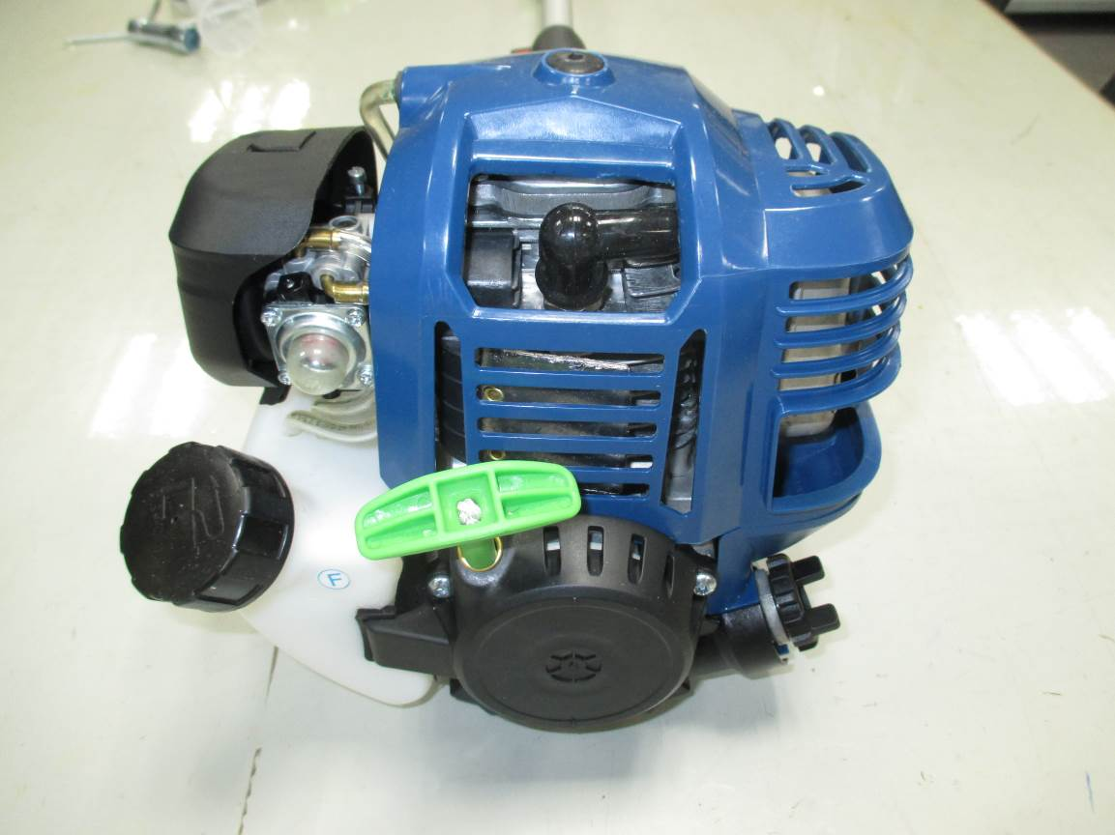

**Fig. 2 Product overview**

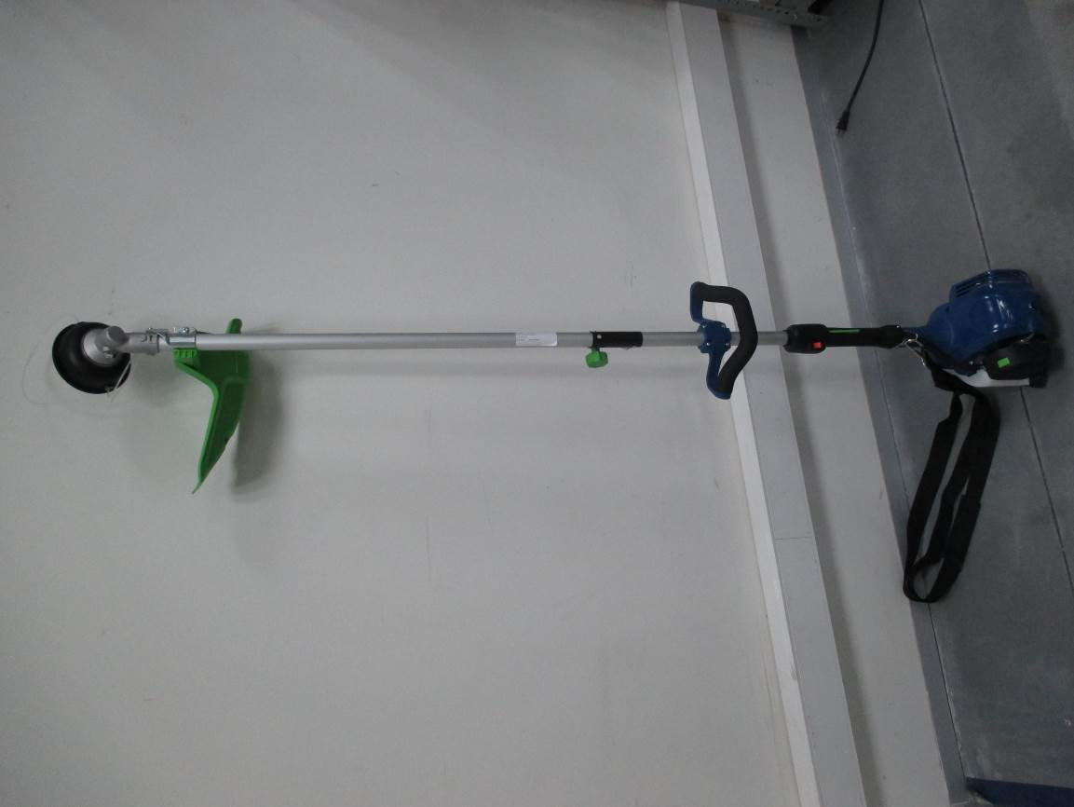

|  |  |  |
| --- | --- | --- |
| **No.** | **Part Name** | **Purpose** |
| 1 | Fuel tank cap | Open the cap for refueling |
| 2 | Primer | Pump fuel to engine |
| 3 | Air filter with choke button | Provide clean air to carburettor, choke button for start |
| 4 | Spark plug | Provides spark for ignition |
| 5 | Muffler | Reduces noise and emissions |
| 6 | Oil tank cap | Open the cap to fill engine lubricant oil |
| 7 | Starter Grip | Pull for starting |
| 8 | Cutting line spool | Provide nylon line for string trimming |
| 9 | Cutting head shield | Protecting operator from cutting line and thrown objects |
| 10 | Knob for drive shafts connection | Fixing the front and rear shafts together |
| 11 | Front handle | Hold and guide the product |
| 12 | Rear handle | Hold the product, control the throttle, switch on-off ignition. |
| 13 | Harness hook | Attach harness to the unit. Carry the product on the shoulder if needed. |
| 14 | Choke button | Pushing in the choke only for cold start. |
| 15 | Harness | Carry the unit on the shoulder if needed. |

## TECHNICAL DATA

|  |  |
| --- | --- |
| Product model | S26GSST |
| Engine type | 4-Cycle, air-cooled |
| Engine displacement | 26.5cc (1.586 cu.in) |
| Fuel type | Unleaded gasoline fuel (No mix oil and gasoline. Do not use fuel containing greater than 10% ethanol.) |
| Fuel tank volume | 9.46 oz.(280ml) |
| Enigne lubricant oil type | SAE 30 oil or 10W30 |
| Enigne lubricant oil volume | 2.03 oz. (60ml) |
| Cutting diameter | 17.7inch. (450mm) |
| Trimmer line diameter | 0.098in (0.095in also could be used) |
| Approximate unit weight (without fuel) | 11 - 11.24lbs. (5.0-5.1 kg) |

# ASSEMBLY INSTRUCTIONS

## UNPACKING

This product requires assembly.

Carefully remove the product and any accessories from the box. Make sure that all items listed in the packing list are included.

Inspect the product carefully to make sure no breakage or damage occurred during shipping.

Do not discard the packing material until you have carefully inspected and satisfactorily operated the product.

If any parts are damaged or missing, please call 1-800-261-3981 for assistance.

Image media/image13(2).emf missing **WARNING!**

Do not use this product if any parts on the packing list are already assembled to your product when you unpack it. Parts on this list are not assembled to the product by the manufacture and require customer installation. Use of a product that may have been imporperly assembled could result in serious personal injury.

## Packing contents

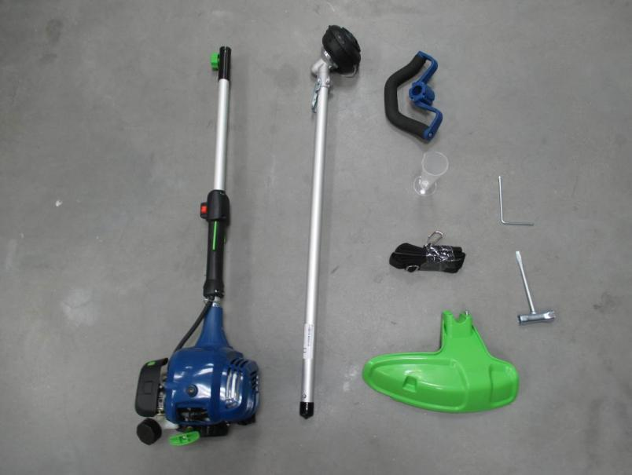

1-Trimmer Assembly(Engine with rear shaft).

2-Front handle Assembly(Front handle and holder with 4 screws pre-assembly).

3-Front shaft with cap.

4-Cutting line spool

5-Cutting head shield with 1 screw pre-assembly

6-Harness

7-1pc screw driver

8-1pc wrench for spark plug

9- Empty bottle with marking 2.03 oz. (60ml) label which is only used for adding engine lubricant oil conveniently and properly.

10-Paper funnel which is only used for pouring engine lubricant oil to the bottle conveniently.

11-Operator’s manual(Quick start and Quick assembling guide)

Image media/image13(3).emf missing **WARNING!**

To prevent accidental starting that could cause serious personal injury, always disconnect the engine spark plug wire from the spark plug when assembling parts.

Image media/image13(4).emf missing **WARNING!**

Never install, remove, or adjust any attachment while power head is running. Failure to stop the engine can cause serious personal injury.

## Installing the cutting line spool

1. Rotate the hub slowly to align the hole in the hub with the hole in the gearbox.
2. Lock the hub firmly using the screw driver provided by aligning and inserting through the two holes as show in the picture. 3. Screw the spool in place and turn the spool counter clockwise until it could not rotate any more with the locked hub.

Image media/image13(5).emf missing **WARNING!**

The cutting line spool must be fixed firmly with the hub. Failure to fix the cutting line spool with the hub can result in serious personal injury.

## Installing the cutting head shield

Image media/image13(6).emf missing **WARNING!**

The line cut-off blade on the cutting head shield is sharp. Aviod connect with the blade. Failure to aviod contact can result in serious personal injury.

1.Remove the screw from protection guards.

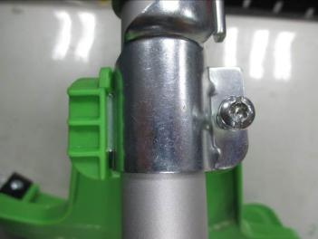 2.Insert the left tab into the slot on the protecting guard. 3.Align the screw hole in the mounting bracket with the screw hole int the protection guards. 4.Tighten the screw through the mounting bracket and into the protection guards by the screw driver provided.

## OPERATIONS

Image media/image13(8).emf missing **WARNING!**

Do not allow familiarity with this product to make you careless. Remember that a careless fraction of a second is sufficient to inflict serious injury.

Always wear eye protection with side shields marked to comply with ANSI Z87.1, along with hearing protection.Failure to do so could result in objects being thrown into your eyes and other possible serious injuries.

Do not use any attachments or accessories not recom-mended by the manufacturer of this product. The use of attachments or accessories not recommended can result in serious personal injury.

Operation of this equipment could create sparks that can start fires around dry vegetation. A spark arrestor may be required. The operator should contact local fire agencies for laws or regulations relating to fire prevention requirements.

## ADDING/CHECKING ENGINE LUBRICANT

**NOTICE:**

1.Attempting to start the engine before it has been properly filled with lubricant will result in equipment failure.

2.Engine lubricant has a major influence on engine performance and service life. This unit is shipped without engine lubricant.

3. Always use a 4-cycle engine lubricant that meets or exceeds the requirements for API service classification SJ. SAE 30, 10W30, or 10W40 are all acceptable lubricants to use in this product. Non-detergent or 2-stroke engine lubricants will damage the engine and should not be used.

4.Check lubricant level before each use.

**To add engine lubricant: Inital use**

1.Remove the cap from the empty lubricant bottle provided.

2.Pour 60ml 4-cycle engine lubricant oil into lubricant bottle with paper funnel.

3.Unscrew the oil cap from the eninge and remove.

4.Pour the 60 ml lubricant oil into oil fill hole. Replace and secure the oil cap.

**To check engine lubricant level before each use:**

1. Separate the attahment from the power head.

2. Set power head on a flat level surface with shaft parallel to surface.

3.Unscrew the oil cap and remove.

4.Lubricant level should fall within the top of oil fill hole(the top of screw thread).

5.If level is low, add engine lubricant until the fluid level rises to the top of oil fill hole( the top of screw thread) and does not overfill.

6.Replace and secure the oil cap.

NOTICE:

Do not overfill. Overfilling the crankcase may cause excessive smoke, oil loss, and engine damage.

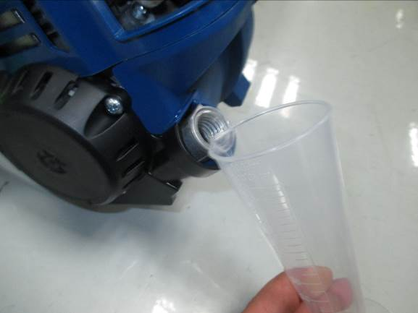

## FUELING AND REFUELING THE TRIMMER

Image media/image13(9).emf missing WARNING:

Gasoline and its vapors are highly flammable and ex-plosive. To prevent serious personal injury and property damage, handle it with care. Keep away from ignition sources and open flames, handle outdoors only, do not smoke and wipe up spills immediately.

Always shut off engine before fueling. Never add fuel to a machine with a running or hot engine. Move at least 30 ft. from refueling site before starting engine. Do not smoke and stay away from open flames and sparks. Never operate the unit without the fuel cap securely. Failure to safely handle fuel could result in serious personal injury.

1. Remove the fuel tank cap by turing counterclockwise.Rest the cap on a clean surface.
2. Carefully pour fuel into the tank. Avoid spillage.
3. Immediately replace fuel cap and hand tighten by turning it clockwise.

4. Wipe up any spilled fuel.

Note: Visually inspect to see if fuel level is low. If fuel is low, refill with unleaded fuel carefully without overfilling and tighten the fuel tank cap immediately.

This unit has a 4-cycle engine. Do not mix oil with gaoline

The use of old fuel is the most common cause of performance problems. Use only fresh, clean unleaded gasoline(less than 30 days old).

Dispose of old fuel according to federal, state and local regulations.

Drain the tank and run the engine dry before storing the unit.

Do not use E15 or E85 fuel(or fuel containing greater than 10% ethanol) in this product. It will damage the unit and void your warranty.

# Starting and stopping

Trimmer should be on a flat, bare surface for starting.

## To start a cold engine:

1.Slowly press the primer bulb 5-10 times.

NOTE: After the 7th press, fuel should be visible in the primer bulb. If it is not, continue to press the primer until you see fuel in the bulb.

■ 2. Push the choke button in to set the choke to FULL CHOKE position.

NOTE: Do not squeeze the throttle trigger because of the choke will be pop out automatically.

■ 3.Pull the starter grip /cord until resistance is detected.Rapidly pull3 to5 times or until you hear engine turn over or it begins to start.

4.If engine does not start,release choke by squeezeing throttle trigger and green choke button pops out

a. Engine is now in the run position.

b. Rapidly pull starter grip/cord until engine starts.

5. Allow the engine to run for 10 seconds, then Squeeze throttle to provide fuel to engine and use for intended task.

Note: The choke button is only used when starting a cold engine. Never push the choke button in once the engine has been turnover or run. Otherwise the engine could be damaged or not run due to FULL CHOKE.

## To restart a warm engine:

Do NOT push choke button in.

a. Ensure primer bulb has fuel inside.

b.Rapidly pull starter/grip until engine starts.

C .Squeeze throttle to provide fuel to enigne and use for intened task.

## To stop the engine:

To stop the engine, depress the STOP switch to the stop

position “STOP”.

## IF ASSISTANCE IS REQUIRED FOR THIS PRODUCT:

Do not return this product to the retail store where it was purchased. Please call our Customer Service Department for any issues you may have.

For Help Call: 1-800-860-4050

# OPERATING THE TRIMMER

**WARNING:**

Engine housing can become hot during trimmer operation. Do not rest or place your arm, hand, or any body part against the engine housing during trimmer operation. Only hold the trimmer as shown in figure 11 with all body

parts clear of engine housing. Extended contact with the engine housing can result in burns or other injuries.

Always position the unit on the operator’s right side. The use of the unit on the operator’s left side will expose the user to hot surfaces and can result in possible burn injury.

To avoid burns from hot surfaces, never operate unit withthe bottom of the engine above waist level.

## Engage cutting head spool/ Stop

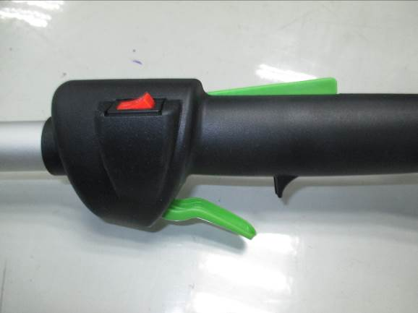The cutting head spool will be engaged if the operator squeezes the throttle lever and then squeezes the throttle lever release to increase the engine speed.

Throttle lever

Ignition switch

The engine will be stop when depressing the switch in “STOP” position.

Note: This ignition switch will come back to ON position automatically.

Throttle lever release

## Working

1. Hold the trimmer with your right hand on the rear handle and your left hand on the front handle. Keep a firm grip with both hands while in operation. Trimmer should be held at a comfortable position with the rear handle about hip height.

2.Keep your body and feet in safety distance to cutting head.

3. Squeezing the throttle lever to full speed before cutting.

4. The cutting line should run parallel to the ground surface.

## To adjust the trimming line length

The line spool has bump feed function. The line will be extended by tapping the spool head shortly and lightly onto the ground while the unit is running at high speed.

1. Run engine at high speed.
2. Tap the spool head on bare ground to release line.
3. A blade in the cutting head shield will cut the line to the proper length if any excess line is released.

Note:Do not hold the spool head on the ground while the unit is running.

The line releases each time the spool head is tapped.

Always keep the trimming line fully extended. Line release becomes more difficult when the cutting line gets shorter.

## Tips for best trimming

1. Avoid hot surfaces by always keeping the tool away from your body.
2. Cut all grass from top to down.his will prevent grass from wrapping around the shaft housing and string head which could cause damage from overheating. If grass becomes wrapped around the string head, STOP THE ENGINE, disconnect the spark plug wire, and remove the grass.

3. Use the tip of line to trim grass; do not force string head into uncut grass.

4.Avoid trees, flowers, stones, walls and other objects which can cause the line breakage.

5.Check and feed the line regularly to maintain full cutting width and performance.

# CLEANING AND CARE

The correct and regular cleaning is not only important for the safe use of this product, but also extends its life span.

Image media/image26.emf missing **Warning!** Always stop the engine and wait for cooling down the engine.

Please remove the dust, grass etc. from machine after every application. Clean the machine with a wet cloth. For cleaning difficult to reach areas use a brush.

You may use pressurized air to remove persistent dust.

**Note:** Do not use chemical, acid, alkaline, grinding or other aggressive cleaning agents. They could destroy the surface of the product.

# MAINTENANCE

Image media/image26(1).emf missing

**Warning!**

Always stop the engine and wait for cooling down the engine.Disconnect spark plug wire and move it away from spark plug.

When servicing, use only identical replacement parts.Use of any other parts could create a hazard or cause product damage.

Always wear eye protection with side shields marked to comply with ANSI Z87.1, along with hearing protection.Failure to do so could result in objects being thrown into your eyes and other possible serious injuries.

## Inspection and maintenance item and interval by operator

|  |  |
| --- | --- |
| Item | Hours of Operation |
| Engine lubricant oil level | Every time before use |
| Loosened or lost screws | Every time before use |
| Damage of any part | Every time before use |
| Function of control elements | Every time before use |
| Fuel level | Every time before use |
| Leakage of oil or fuel | Every time before use |
| Cutting line | Every time before use |
| Engine lubricant oil replacement | Every 20 hours. |
| Air cleaner cleaning | Every 20 hours but every 10 hours if work condition has dust. |
| Spark plug check | Every 20 hours |

Remark:

* The maintenance interval is only a recommendation for machine in ordinary operation condition. If there is any abnormal sign of the machine, please do the proper inspection and maintenance immediately.
* The tightening torque should follow the general screw specification of different size, class and material.
* If anything is unclear for you, please contact our service team for help.
* All other repairs or maintenances which are not mentioned here shall only be done by our service team or authorized personnel.

## Engine lubricant Oil Replacement:

Image media/image26(2).emf missing **ATTANTION!** Old engine oil is special waste and has to be disposed according to your local environment protection regulation. Do not pour the oil to garbage can, sewer, soil etc.

1. The engine oil replacement is easier if engine is warm (NOT HOT!).
2. Open the oil tank cap and drain the old oil to a approved container.
3. Return the engine to an upright position and refill with lubricant following the instructions in the Adding/Checking Engine Lubricant section previously in this manual.
4. Clean the dropped oil on the unit if necessary.

## Air Filter Cleaning

1. The air filter elements should be cleaned to provide the engine abundant clean air which benefits for starting, power and life time of engine.
2. Remove the air filter cover. To remove, press the Green button on the top of the cover with thumb and gently push up the cover with index finger.
3. Remove the air filter

4. If only cleaning of the air filter is necessary, take the air filter pad out and clean it with a jet of dry compressed air until all dusts are removed. Wear protecting goggles and mask to protect your health during this work.

1. Reinstall the air filter cover by closing the air filter cover over the button on the housing, then push the cover until it locks securely in the place.

NOTE: Make sure the filter is seated properly inside the cover. Installing the filter incorrectly will allow dirt to enter the engine, causing rapid engine wear.

If the nylon filter element is lost, it should be reinstalled by call our Customer Service Department.

## Inspect the Spark Plug

Image media/image26(3).emf missing **Warning! Never does this work if the engine is still warm!**

1. Pull out the spark plug cap and clean the dust in the spark plug area.
2. Screw out the spark plug with the provided socket wrench.
3. Check the ceramic isolation. Replace the spark plug if damaged.
4. Clean the electrodes (metal tip) to refresh the surfaces.
5. Restore the spark plug and its cap.

### Cutting line spool

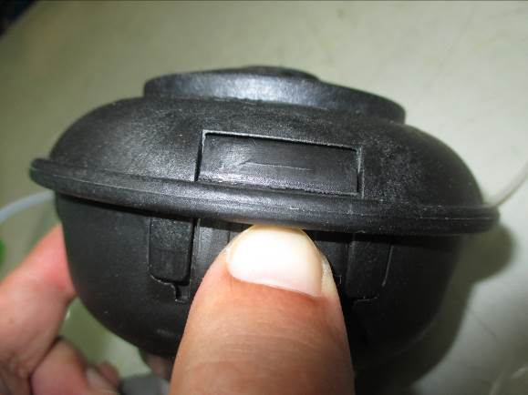 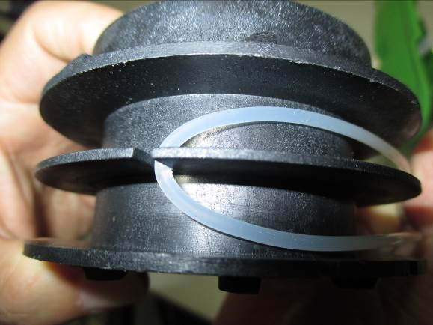 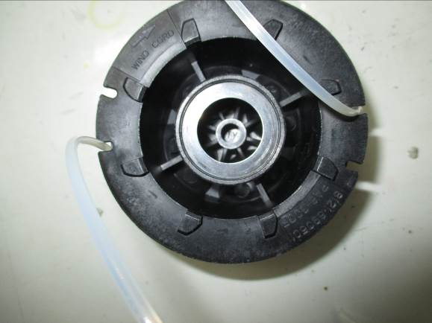 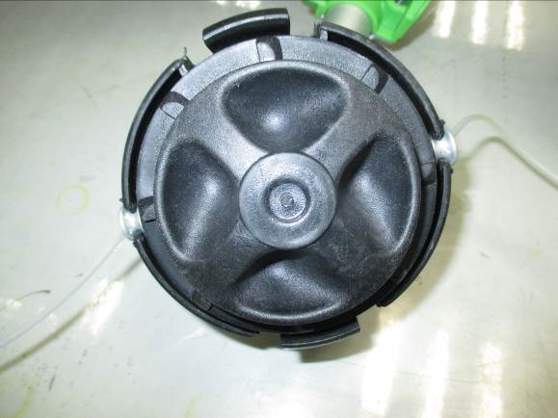

B

A

1. Open the cutting line spool by pressing two release buttons on the side and take out the winding core (Fig. A+B).

C

D

C

1. Divide a spare cutting line in 2 equal halves, fix it in the winding core and start to wind the cutting line in two separated rails (Fig. B). Pls. follow the indicated winding direction on the winding core.
2. Fix the 2 line ends (ca. 15 cm) at the opening to keep the line winded tightly. (Fig. C)
3. Guide the 2 line ends into the holes on the spool housing and restore the spool cover. (Fig. D)

### Carburettor

Do not adjust carburettor unless necessary. If you have trouble with the Carburetor, please contact the after-sales service or authorize professional dealer. Improper adjustment may cause engine damage and void warranty.

# AFTERSALES SERVICE

In all correspondence and spare parts orders, please always include the article number and model type given on the type plate of the product.

Senix Inc.

99 Jackson St #1119

Davidson, NC 28036

Toll Free number: 1-800-261-3981

Emails for support/service:

[support@senixtools.com](mailto:support@senixtools.com)

# DISPOSAL

Waste product should not be disposed of with household waste. Please recycle where facilities exist. Check with your local authority or retailer for recycling advice.

# STORAGE

1. Store the unit out of reach for children and other unauthorized persons in a well-ventilated, dry and frost-free environment.
2. Clean all foreign material from the product. Store idle unitindoors in a dry, well-ventilated area that is inaccessible to children. Keep away from corrosive agents such as garden chemicals and de-icing salts.
3. Protect the unit against dusts.

■ 4. Abide by all ISO and local regulations for the safe storage and handling of gasoline.

When storing 1 month or longer:

■ Drain all fuel from tank into a container approved for gasoline. Run engine until it stops.